**Bowling Action Evaluator Application**

**II Increment Report**

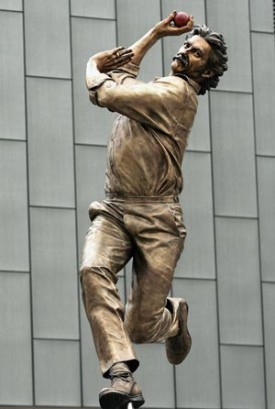

Aditya Deshpande,

Tej Kiran Meka,

Mahesh Vemula,

Prathipati Dharamarao Jagadish

We have collected data samples related to various bowling actions.

Find below are the screen shots of data collected

*Fast bowling action sample data*

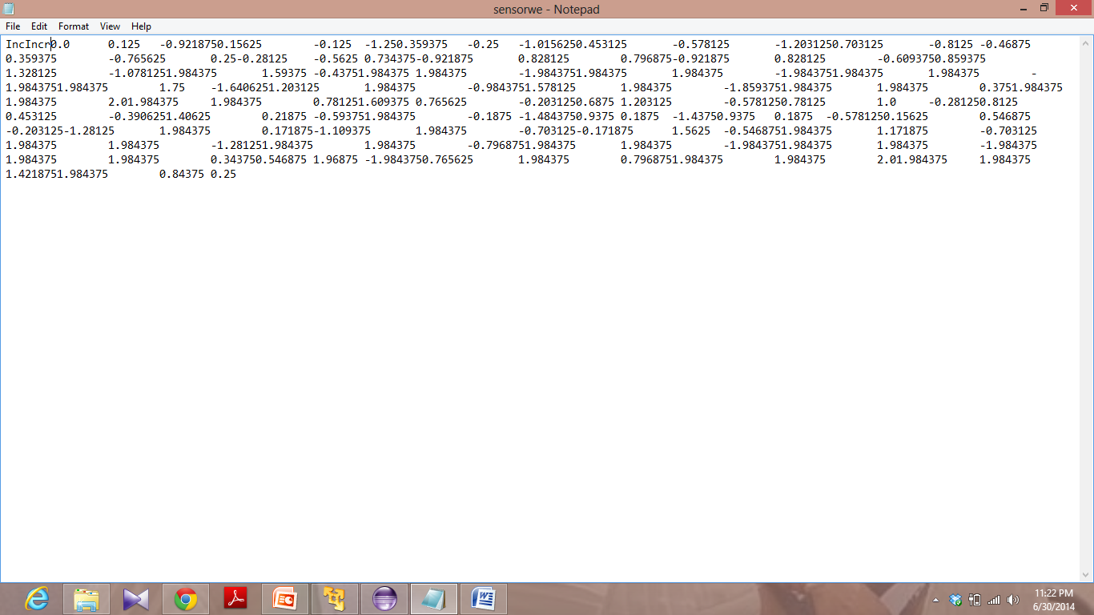

*Fast bowling action sample data*

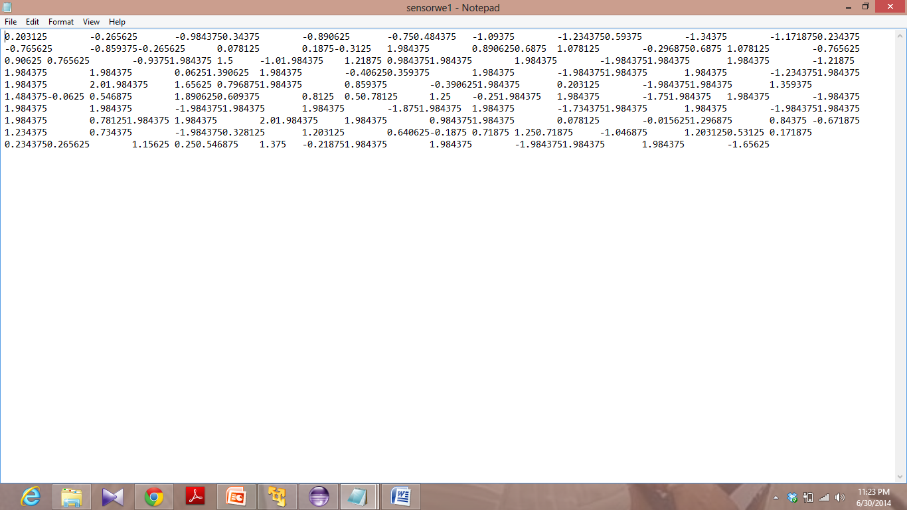

*Medium pace bowling sample data*

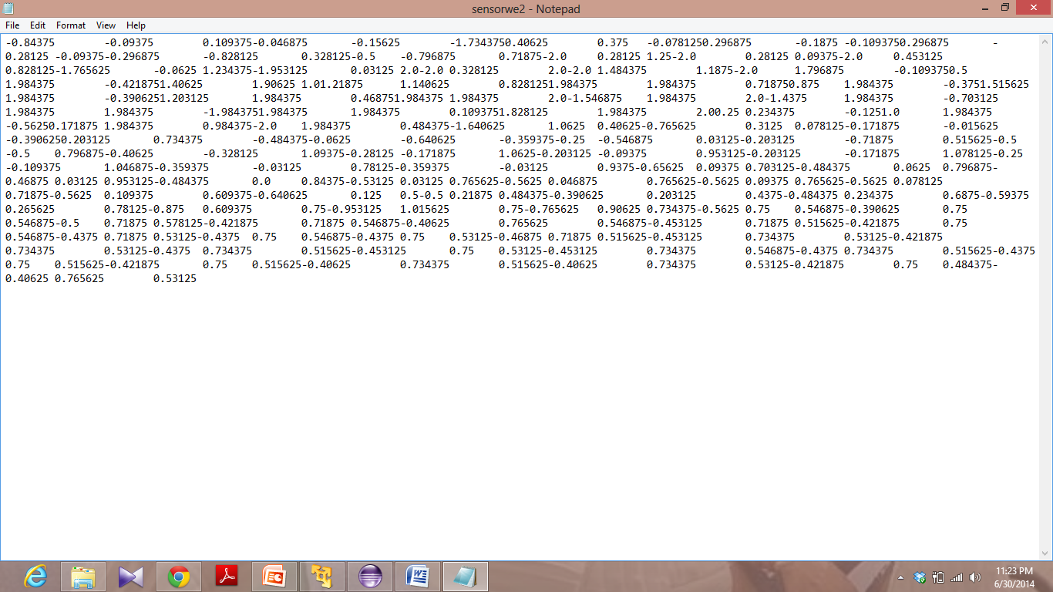

*Medium pace bowling sample data*

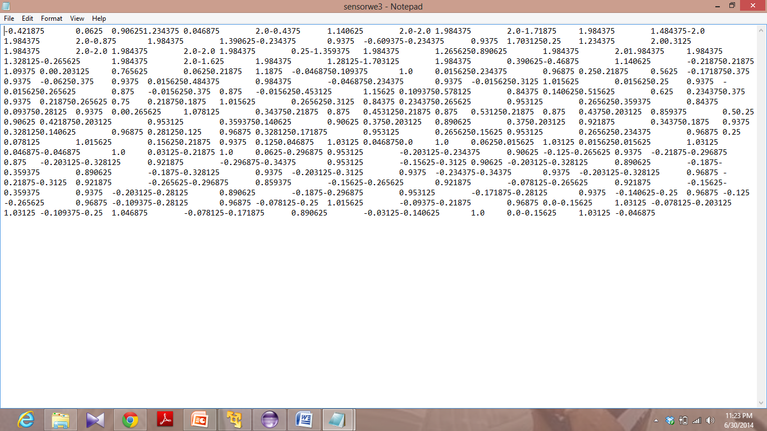

*Spin bowling action sample data*

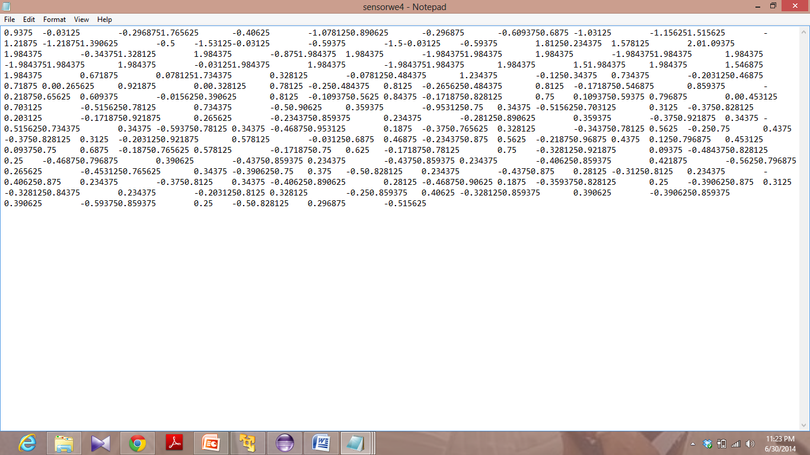

*Spin bowling action sample data*

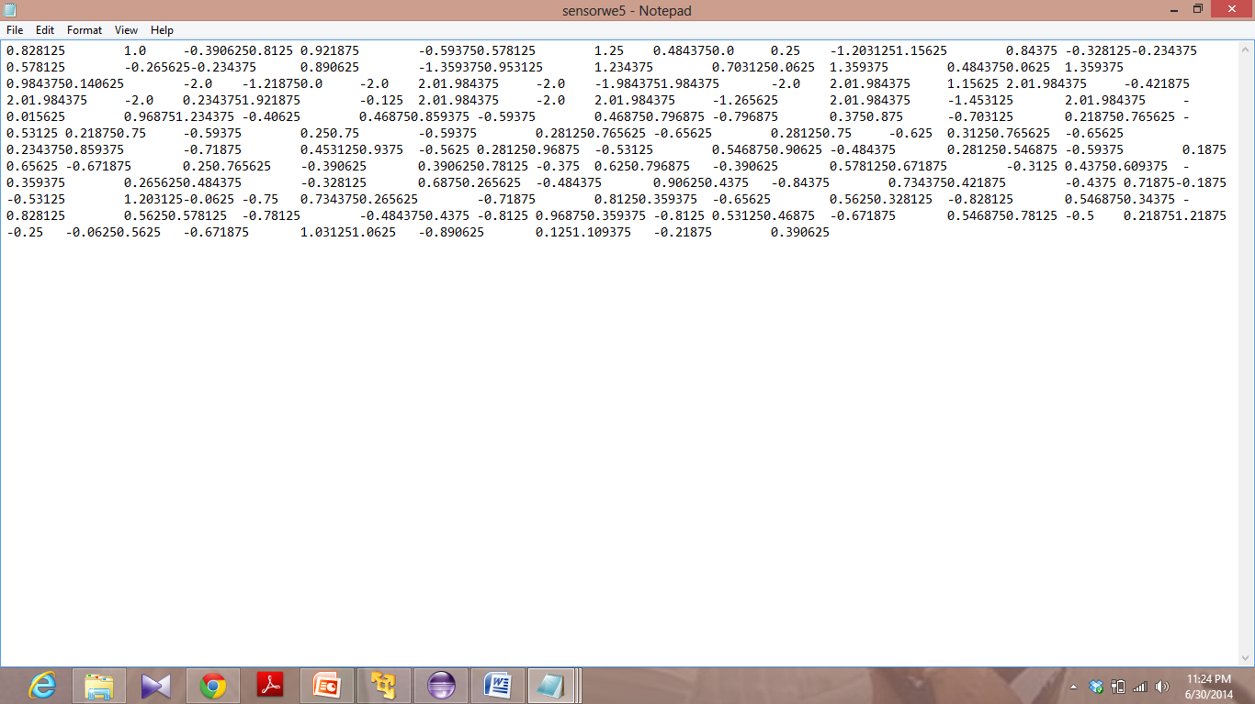

**Android App**

We are building an android mobile app for our project.

Sample screenshots of our app

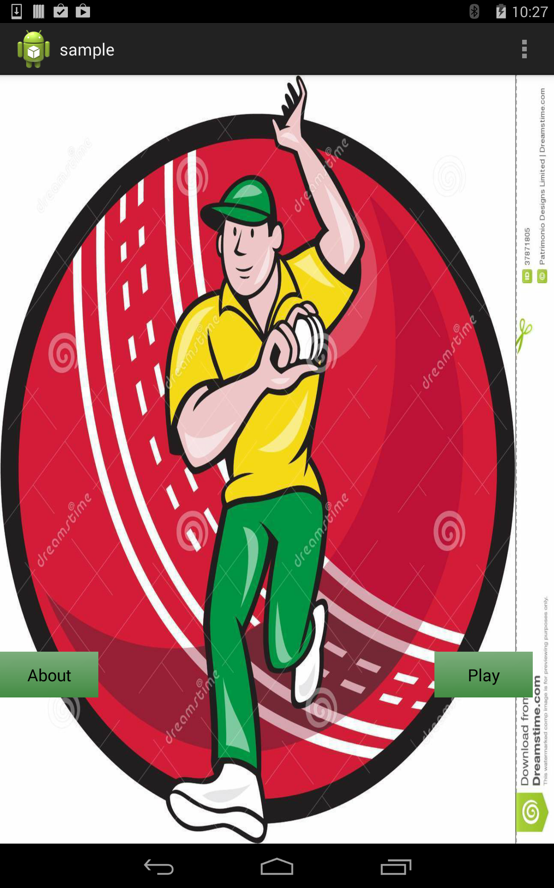

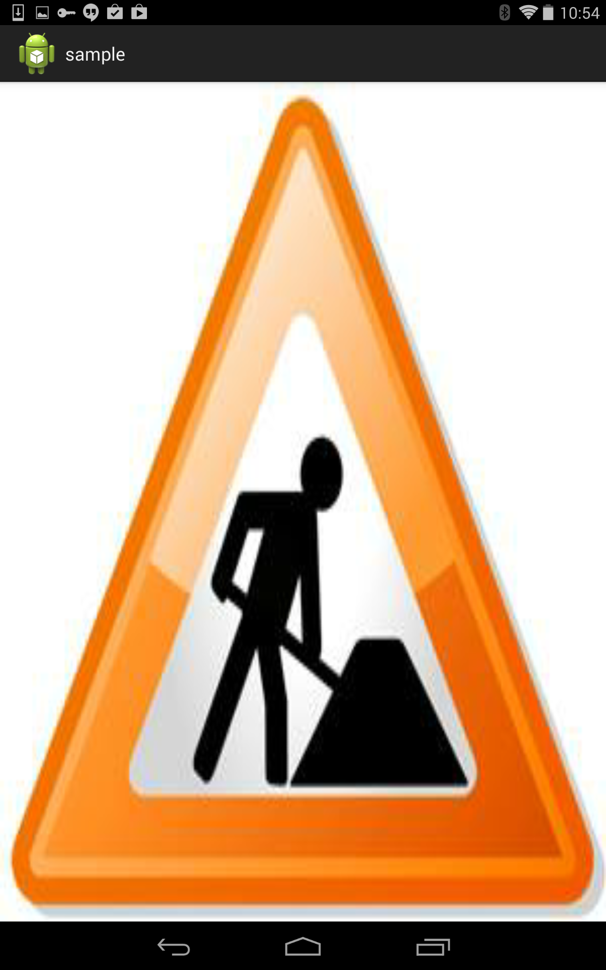

**Tasks to be done:** We have to develop the application and then train the application with these data of different bowling actions. When training is done. We will test the application with test data in order to evaluate the results.